Hovercraft Controlled By Android

ABSTRACT
A hovercraft is a non-wheeled vehicle that can hover over land as well as water easily using high powered fans and aerodynamic design. We here propose an advanced hovercraft that uses high rpm motors interfaced with an AVR family micro-controller to achieve desired functionality. The motor below hovercraft rotates at a very high RPM that allows it to generate a force enough to make it hover on the surface thus reducing the friction below it to minimum. Then we use the motor propeller mounted behind it to push the hovercraft in forward direction. Now we also need to use a servo motor attached to the hovercraft rudder that helps the hovercraft to move in desired directions by bending the air at accurate angles. The system works collectively to hover while continuously managing servo as well as propeller motor to drive the hovercraft as desired. Now to control the hovercraft we here use an android application. The android application sends movement commands to the hovercraft circuit. The circuit consists of a Bluetooth receiver to receive and process these commands. The commands received by receiver are now processed by the microcontroller and it then operates all three motors accordingly as desired by the user.

Hardware Specifications
- Atmega 328 Microcontroller
- 2 High Power Batteries
- Hovercraft Base
- Hovercraft Frame
- Rudder Frame
- Air/Water Resistant Float Material
- Current limiters
- Diodes
- Capacitors
- Resistors
- High Power Motors
- 2 Propellers
- Voltage Regulator
- Bluetooth module

Software Specifications
- Arduino Compiler
- MC Programming Language: Embedded C

ATMEGA328
The Atmel 8-bit AVR RISC-based microcontroller combines 32 KB ISP flash memory with read-while-write capabilities, 1 KB EEPROM, 2 KB SRAM, 23 general purpose I/O lines, 32 general purpose working registers, three flexible timer/counters with compare modes, internal and external interrupts, serial programmable USART, a byte-oriented 2-wire serial interface, SPI serial port, 6-channel 10-bit A/D converter (8-channels in TQFP and QFN/MLF packages), programmable watchdog timer with internal oscillator, and five software selectable power saving modes. The device operates between 1.8-5.5 volts. The device achieves throughputs approaching 1 MIPS per MHz.

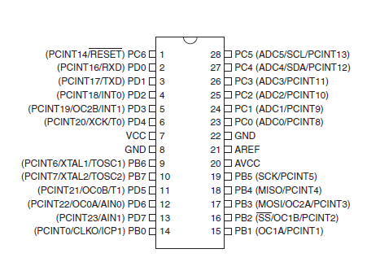

AVR Studio
AVR Studio was created by Atmel in order to help developers to create applications for AVR microcontrollers using C/C++ programming languages. This piece of software comes with a large number of tutorials, which allow the users to get familiar with the application. The program stands as a complete pack for programmers that use C++ and other programming languages.
It provides the users with access to the tools for writing, building and debugging their codes.
The menu of this application is easy-to-use and offers access to powerful tools for both beginners and experienced developers, making it easy for the users to find their way through C/C++ programming. Some of the key features are: “cycle correct” simulator with advanced debugging functionality, rich SDK that enables tight integration of customer plug-ins and compatibility with many Microsoft Visual Studio plug-ins. Also the tool provides a "split window" button that allows the users to work on more than one project at a time.
All in all AVR Studio is a complete tool for programmers which develop, test and debug C/C++ applications; you should give this tool a try as it comes in handy for programming AVR microcontrollers.
Reference
- http://ieeexplore.ieee.org/xpl/articleDetails.jsp?arnumber=6596385&queryText=android%20control%20vehicle&newsearch=true

